**Holy Eucharist Rite II**

**with Prayers for Healing**

Opening Hymn

**The Word of God**

Opening Acclamation (Sung)

***Blessed be the Father, Son and Holy Spirit  
Blessed be His Kingdom, now and ever more  
As in the beginning, now and ever shall be  
World without end, Amen, Amen (Repeat)***

BCP

Collect for Purity 355 The Gloria 356 The Collect of the Day Insert A Prayer attributed to St Francis Insert The Lessons Insert Sequence Hymn

The Gospel The Sermon

The Nicene Creed 358

The Prayers of the People: Form6 392  
 *In the Diocesan Cycle of Prayer, we pray for*

*St. James, Belhaven and St. Mary's, Burgaw*

Rite of Healing` Insert

The Exchange of God's Peace  
Announcements

*Everybody is invited to meet for cake and coffee (and sparkling wine)  
at the "New Rectory" 2908 Hobart Dr in Wilmington,   
on Saturday February 1st starting at 2pm.*

Offering sentence 376

At the presentation of the offering plate, we say:   
***All things come of Thee, O Lord,   
And of Thine own have we given Thee (1 Chronicles 29:14)***

**The Holy Communion**

*Everyone is invited to receive Communion at the Lord’s Table.*

*If you do not wish to receive Communion, you may come to the Altar and receive a Blessing.*

BCP

The Great Thanksgiving: Prayer C 369

The Lord's Prayer 364

The Fraction Anthem

Administration of Holy Communion 365

Communion Hymns

Post Communion Prayer of Thanksgiving 366

The Blessing

Recessional Hymn

The Dismissal

Serving today: Bill Liesman (LEM), George Heroux (Lector)

Next week:

# *Please gather in the Parish Hall for Community and Snacks*

*Our prayer list is posted on our website, as well as past sermons, upcoming bulletins and parish news:*[*www.all-souls-leland.org*](http://www.all-souls-leland.org/)*.*

**The Vestry**

Chip Carroll, Senior Warden

Jane Elks, Robin Hamilton,   
George Heroux, Carol Fesser  
 Stacey Jones, Clerk   
Jackie Rosner, Treasurer

**The Most Reverend Sean W. Rowe**

**Presiding Bishop** The Protestant Episcopal Church In the United States of America

**The Right Reverend Robert S. Skirving Bishop**  The Diocese of East Carolina

**The Reverend Fanny Sohet Belanger Priest-in-Charge**

[rev.belanger@gmail.com](mailto:rev.belanger@gmail.com)

571-431-9373

**Kathy Barker  
Robin Hamilton**   
 Organists

**Sonja Remington**  
Guitarist

L

All Souls Episcopal Church Northwest

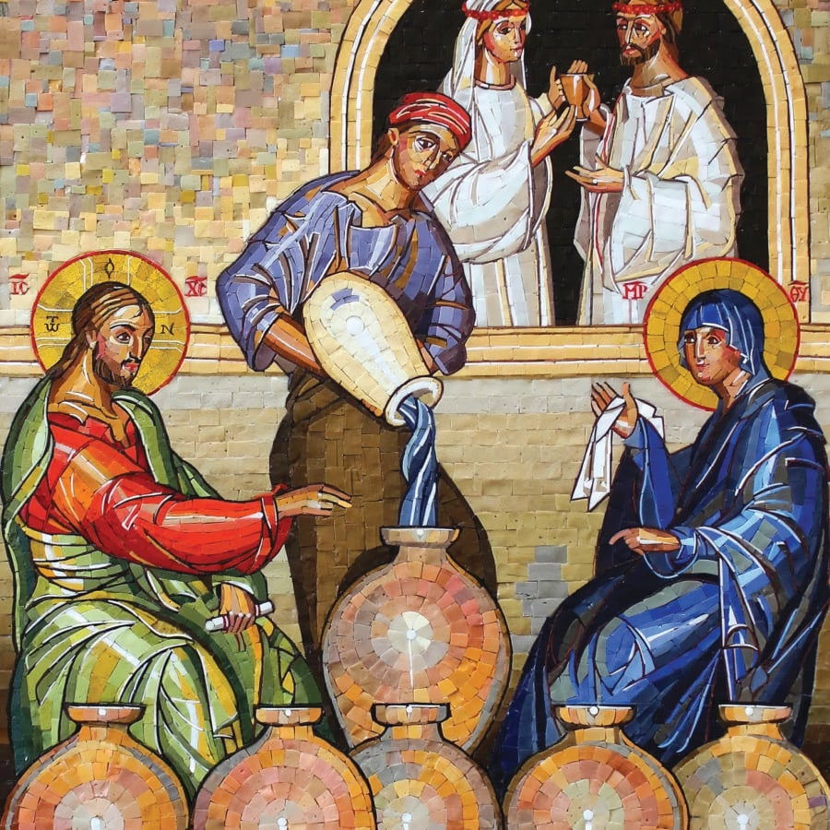

Second Sunday after the Epiphany  
January 19, 2025

5087 Blue Banks Loop Rd

Leland, NC 28451  
[www.all-souls-leland.org](http://www.all-souls-leland.org/)